**HTTP STATUS ERROR 200**

These are the types of Error 200 messages we might see:

200 – Ok

201 – Created

202 – Accepted

203 – Non-Authoritative Information

204 – No Content

205 – Reset Content

206 – Partial Content

**HTTP Status code 200**

* The Http 200 Ok success status response code indicates that the request has succeeded. A 200 response is cacheable by default.
* If the data is not received it shows up with an error cannot get data 200.OK

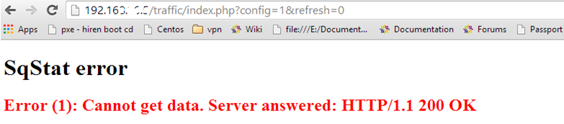

Reason for Error:

* Virus or malware infection that has corrupted or taken control your internet browser.
* Corruption in windows registry from a recent Windows-related software change
* An external rouge program has maliciously infected browser-related files.

**HTTP Status Code 201**

* The HTTP **201 Created** success status response code indicates that the request has succeeded and has led to the creation of a resource.
* The common use case of this status code is as the result of a post request.

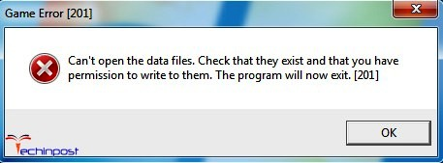

Reason for error:

* Http status 201 indicates that as a result of http post request, one or more new resources have not been successfully created on the server.

**HTTP Status Code 202**

* HTTP status code 202 means that request has been accepted for processing, but the processing has not been completed.
* The request might or might not eventually be acted upon, as it might be disallowed when processing actually takes place.

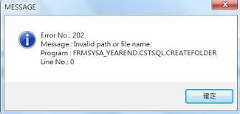

Reason for error:

* The request is not committed because HTTP does not allow you to send an asynchronous response indicating the outcome of the request later.
* It is intended for cases where the request is handled by another process or server, or for batch processing

**HTTP Status Code 203**

* HTTP **203 Non-Authoritative Information** response statuses indicates that the request was successful.
* But the enclosed payload has been modified by a transforming proxy from that of the origin.
* This is typically used to monitoring or backing up recourse.

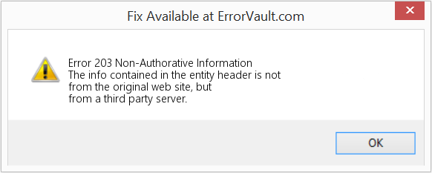

Reason for Error:

* This response indicates the returned metadata is not the same as what is available in the origin server.
* The data has been obtained from a third party copy.

**HTTP Status Code 204**

* This indicates that a request has succeeded, but the client doesn’t need to navigate away from its current page.
* This might be used in doing save and continue editing functionality of a wiki site. That the response would be sending to indicate the editor should not be changed by some other page.

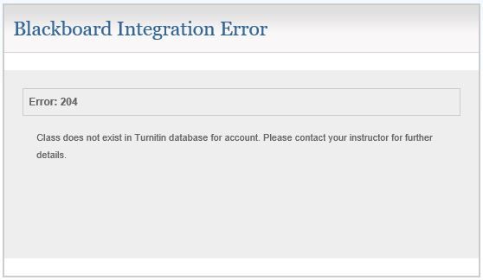

**HTTP Status Code 205**

* It tells the client to reset the document view, so for example to clear the content of a form, reset a canvas state, or to refresh the UI.
* If a user fills out a form, and submits it, a status of 205 means the server is asking the browser to clear the form.

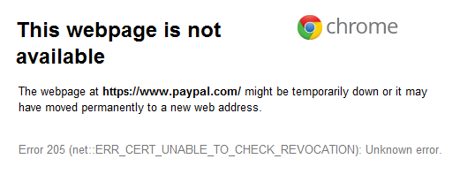

**HTTP Status Code 206**

* This status code indicates that the request has succeeded and the body contains the requested ranges of data.
* This is used by advanced caching tools, when a browser requests only a small part of a page, and just that section is returned.

